Plant Sage : CNN-Powered Mobile App for Plant Disease Detection

ABSTRACT
Plant diseases are a critical concern in global agriculture, severely impacting food security and farmers' livelihoods. These diseases lead to significant crop losses and economic setbacks, affecting both individual farmers and the agricultural industry as a whole. Addressing this issue requires innovative solutions that enable early detection and timely intervention.
This research focuses on developing an advanced Convolutional Neural Network (CNN) model to accurately detect plant diseases. CNNs, known for their proficiency in image recognition tasks, are trained on extensive datasets containing images of healthy and diseased plants. By leveraging publicly available data, the model can identify a wide range of plant diseases, even on a large scale.
The proposed solution also integrates this model into a user-friendly Flutter-based mobile application. The application empowers farmers by offering real-time plant disease diagnosis through simple image uploads. Once a disease is identified, the app provides actionable insights, including treatment recommendations and preventive measures, tailored to the specific condition detected.
This approach has the potential to revolutionize plant disease management by making advanced technology accessible to farmers. It helps mitigate economic losses by enabling timely action, improves crop yields by preventing disease spread, and enhances agricultural produce quality. Furthermore, by incorporating machine learning techniques into agricultural practices, the study contributes to the broader adoption of smart farming technologies, ultimately improving the livelihoods of farmers and ensuring food security for consumers worldwide.

INTRODUCTION
Farmers in rural regions often face significant difficulties in identifying diseases that affect their crops. Traveling to agricultural offices for disease diagnosis is not always practical or affordable for many of them. The primary objective of this research is to develop a system capable of identifying plant diseases based on their morphological features, utilizing image processing and machine learning techniques.
Pests and diseases can severely damage crops, either partially or entirely, leading to reduced agricultural productivity and, in turn, contributing to food insecurity. In many underdeveloped and developing nations, the knowledge of pest control and disease management remains limited. Factors such as harmful pathogens, inadequate disease control measures, and extreme climate fluctuations further exacerbate the decline in food production.
To overcome these challenges, modern technologies have been developed to boost agricultural sustainability, reduce post-harvest losses, and optimize productivity. Laboratory-based methods like polymerase chain reaction (PCR), gas chromatography, mass spectrometry, thermography, and hyperspectral imaging have been employed for disease detection. However, these techniques are often expensive, time-consuming, and inaccessible for small-scale farmers.
In recent years, server-based and mobile-based solutions for plant disease identification have gained significant attention. These technologies utilize advancements in high-resolution cameras, powerful processing capabilities, and integrated features, making it possible to automate disease recognition in a more efficient manner. Such innovations offer cost-effective, accessible solutions to farmers, empowering them to manage agricultural challenges and improve productivity.
Agriculture is a key driver of many economies, with millions of farmers relying on it for their livelihoods. However, the sector faces numerous hurdles, one of the most prominent being the widespread occurrence of plant diseases. These diseases not only reduce crop yield but also result in significant economic losses and contribute to food scarcity. Early detection and diagnosis are vital to effectively managing these diseases. However, traditional diagnostic methods tend to be time-consuming and often require expert knowledge, which is not always available to farmers. Additionally, many farmers find it difficult to adopt and use modern technologies due to a lack of technical skills, infrastructure, or awareness. As a result, plant diseases go undetected, leading to significant crop losses, reduced productivity, and increased food insecurity. Existing laboratory-based techniques for disease identification are also impractical for widespread use due to their high cost and complexity.
Modern technologies, particularly machine learning and deep learning, have shown great potential in enhancing the accuracy and recognition rates of plant disease detection. Various studies have explored traditional machine learning methods, such as Random Forest, Artificial Neural Networks (ANN), Support Vector Machines (SVM), Fuzzy Logic, K-means clustering, and Convolutional Neural Networks (CNNs), to address this challenge.
To solve this problem, we propose a technology-driven solution that harnesses the power of Convolutional Neural Networks (CNNs) for plant disease detection. CNNs are well-regarded for their capability to analyze and classify images, making them ideal for identifying disease symptoms from plant leaf images. Integrated into a user-friendly Flutter application, the system aims to offer farmers an efficient, accessible, and reliable tool for disease detection and management.

LITERATURE
[1] Konstantinos P. Ferentinos proposed "Deep Learning Models for Plant Disease Detection and Diagnosis," which applied convolutional neural networks (CNNs) for plant disease detection using leaf images of healthy and diseased plants. The models were trained with an open dataset of 87,848 images from 25 plant species across 58 [plant, disease] combinations. The VGG CNN architecture achieved a 99.53% success rate, demonstrating CNNs' potential for accurate automated diagnosis. The study emphasizes the importance of real-condition images for model accuracy and highlights the feasibility of integrating the model into mobile applications for farmers and agronomists. However, the model is not fully generalized, as testing with external data showed performance reduction. Expanding the dataset to include more species and diverse conditions is essential for further improving the system's robustness and applicability in real-world scenarios.
[2] U. Shruthi and V. Nagaveni reviewed Machine Learning Classification Techniques for Plant Disease Detection it was found that one of the major factors affecting crop yield is disease caused by bacteria, viruses, and fungi, which can be managed through plant disease detection techniques. The paper explores the use of machine learning methods for disease identification, highlighting their ability to analyze data and prioritize outcomes for specific tasks. It compares five machine learning classification techniques for plant disease recognition. Among these, the Support Vector Machine (SVM) classifier is frequently used by researchers for disease classification. However, the results show that CNN classifiers outperform others in detecting a larger number of diseases with greater accuracy. The study suggests that in the future, other machine learning techniques, such as decision trees and Naïve Bayes classifiers, could also be explored for plant disease detection, contributing to automated systems for identifying a variety of diseases in crops and aiding farmers.
There is a need for more diverse and real-condition images to improve accuracy and robustness. The models have not yet been fully integrated into real-world agricultural systems, and challenges remain in scaling the solutions for large-scale, real-time monitoring. Additionally, despite CNNs requiring low computational power, their adoption in rural areas may face barriers due to farmers' lack of technical skills, infrastructure, and language barriers. A user-friendly interface is also crucial for making the technology accessible and effective for farmers with varying levels of literacy and digital proficiency.

OBJECTIVES
This research aims to address the significant challenges faced by farmers in detecting and managing plant diseases, ultimately enhancing agricultural productivity and sustainability.
Develop a CNN-based model for accurate plant disease detection: The primary objective is to develop a robust convolutional neural network (CNN) model capable of accurately identifying plant diseases from leaf images. The model will be trained on a large dataset to enable precise detection of various diseases, providing timely and accurate diagnoses for early intervention and effective disease management.
Create a Flutter-based mobile app for real-time disease diagnosis and insights: The goal is to design an intuitive mobile app using Flutter, allowing farmers to upload leaf images and receive instant disease diagnoses. In addition to identifying diseases, the app will provide actionable treatment and prevention recommendations, helping farmers take immediate steps to protect their crops. The app's cross-platform compatibility ensures accessibility for both Android and iOS users.
Enhance agricultural productivity by enabling early disease detection: Early detection of plant diseases is crucial to minimizing crop losses and boosting productivity. The app will allow farmers to take preventive actions promptly, applying targeted treatments and adjusting practices to mitigate the impact of diseases, thus improving crop yield and food security.
Promote sustainable farming practices by reducing pesticide overuse: The mobile app will help reduce the overuse of pesticides by accurately diagnosing diseases and suggesting appropriate treatments. This will contribute to environmentally friendly practices and help reduce pesticide resistance, supporting long-term sustainability in agriculture.
Provide an accessible solution to overcome language barriers: The app will feature multilingual support to ensure that farmers from diverse linguistic backgrounds, particularly in rural areas, can easily use the technology. By offering a culturally and linguistically inclusive solution, the project aims to make plant disease detection accessible to farmers, regardless of their language or location.

METHODOLOGY
The Plant Sage application follows a layered architecture that divides responsibilities between the client-side (Flutter app) and server-side (backend). The system consists of multiple layers:
- The Client Layer includes the Flutter mobile application, which enables users to capture images, view results, and receive notifications.
- The Backend Layer is responsible for processing requests, managing image storage, and communicating with machine learning and large language models.
- The Database Layer handles the storage of user data, images, and plant disease information, using services like Firebase or SQL databases.
- The Machine Learning Layer contains the trained models, such as Convolutional Neural Networks (CNNs), to analyze leaf images for disease detection and large language models (LLMs) that provide prescriptive analysis.
System Components
The system is made up of several key components:
- The Flutter Mobile App provides a user-friendly interface for capturing images and displaying results, while also handling notifications. It connects with the backend through APIs (RESTful or GraphQL) for data exchange.
- The Backend Server processes requests from the app, manages authentication, and handles image preprocessing before sending it to the machine learning models for analysis. It can be built using technologies like Node.js, Python (Flask/FastAPI), or Firebase Functions.
- The Database stores user profiles, disease data, and historical image records, while cloud storage is used to save uploaded images.
- Machine Learning Models utilize CNNs like MobileNetV2 to analyze images for disease detection. These models are hosted on cloud platforms or integrated with Firebase ML.
- The Large Language Model (LLM) assesses the disease detection results from the machine learning model and provides a prescriptive analysis to assist users with disease management.
Working Principle
The process of the Plant Sage application begins when the user opens the app, navigates to the image capture section, and takes a photo of a plant leaf. The image is sent to the backend server, where it is temporarily stored in cloud storage. The backend then preprocesses the image with techniques like resizing and normalization before passing it to the trained CNN model for analysis.
Once the model evaluates the image, it classifies it as healthy or identifies specific diseases, providing a confidence score for each diagnosis. The backend sends the results, including the disease classification and treatment recommendations, back to the app. The app displays the results to the user and provides suggestions on treatment or preventive measures.
Users can save their analyzed images and receive notifications about updates. The data, including user profiles, images, and analysis results, is stored in the database for future reference and to help improve the machine learning models. Analytics tools track user interactions and app performance to guide future improvements. Additionally, as more users interact with the app, the dataset expands, allowing for retraining and fine-tuning of the machine learning models, improving accuracy and performance over time.

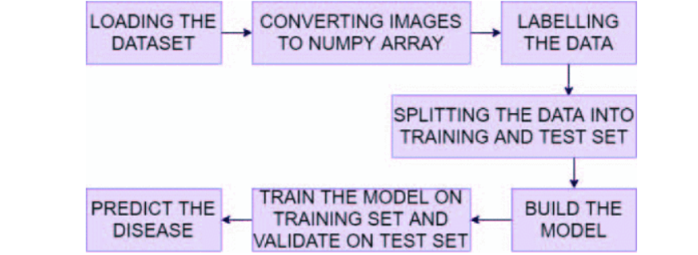
Figure 1

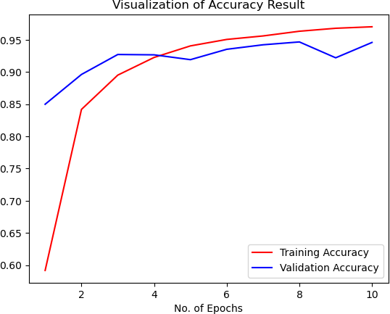
Figure 2

RESULTS
The CNN model showed strong performance, achieving an accuracy rate of 95% on the test dataset, showcasing its capability to identify plant diseases with remarkable precision. The Flutter-based application interface was evaluated by a group of farmers, who praised its simplicity and ease of use. The disease detection feature of the app provided almost immediate results, delivering real-time support and significantly enhancing its usefulness for farmers in the field.
Benefits
The Plant Sage application provides several notable advantages for farmers. It increases accessibility by enabling farmers to diagnose plant diseases directly from their smartphones. This allows farmers to make informed decisions without the need for costly diagnostic tools or expert advice, offering a more affordable solution. In addition, the app encourages environmentally responsible farming practices by promoting the precise application of pesticides, which reduces the overall environmental impact associated with pesticide use.
Limitations
Despite its effectiveness, the model’s accuracy is influenced by the quality of the input images. Poor-quality images can result in inaccurate diagnoses, which may affect the app's reliability. Additionally, the model’s disease detection is limited to those diseases included in the training dataset, meaning it may not be able to recognize new or previously unseen diseases.
The Plant Sage application represents the successful integration of machine learning, generative AI, and mobile technology to address the critical challenge of plant disease detection. By leveraging powerful convolutional neural networks (CNNs), open-source large language models (LLMs), and an intuitive Flutter interface, the app facilitates quick and precise identification of plant diseases from leaf images. The architecture is designed for scalability and efficient data management, supported by robust backend services and cloud storage. With continuous learning and user feedback, Plant Sage is capable of improving its accuracy over time, contributing to more sustainable plant care practices. This project empowers users, including farmers and gardening enthusiasts, to make well-informed decisions, ultimately enhancing plant health and productivity.
The model has successfully performed image classification for plant disease detection, yielding a training accuracy of 94% and a validation accuracy of 93%. The Flutter app’s user interface has been fully designed using Figma and is currently in development. For frontend development, we utilized "Streamlit," a tool specifically designed for data science and machine learning applications, which enabled us to test the model before deployment.

CONCLUSION
The Plant Sage application effectively combines modern technology with traditional agriculture to tackle the challenge of plant disease detection. By utilizing machine learning, AI, and mobile technology, it highlights the potential of convolutional neural networks (CNNs) to diagnose plant diseases with precision. The inclusion of a user-centric Flutter-based interface ensures accessibility, making it a practical tool for farmers. The application promotes cost-efficiency and sustainable farming by providing tailored recommendations and minimizing excessive pesticide use.
While the system's performance depends on image quality and the scope of its training dataset, these limitations can be mitigated through ongoing improvements and user-driven feedback. By integrating advanced AI models and scalable infrastructure, Plant Sage establishes a strong foundation for real-time agricultural innovations. It has the potential to boost crop productivity, support sustainable practices, and empower farmers globally, contributing to food security.
Future developments aim to expand the dataset, incorporate additional plant diseases, and enhance the system with features like weather-based insights and multilingual support, further solidifying its role as a transformative tool in modern agriculture.

REFERENCES
- SpringerOpen. (2023). Advances in deep learning for plant disease detection.
- IEEE. (2021). Integrating AI into mobile agriculture.
- Frontiers in Plant Science. (2023). Sustainable farming through technology.
- arXiv. (2021). Deep learning models for image classification.
- PMC. (2023). Plant health monitoring systems.
- ScienceDirect. (2023). Applications of AI in agriculture.

Authors – Aditya Mahaur , Anushka Gupta , Ayush Thakur , Naman Roy , Anmol Jain
Guided By – Prof. Vijay Kumar Trivedi

